Cointegration and ECM: AUDUSD and USDCAD
Method 27 / Engle-Granger on log closes / one-lag ECM / Alpari D1 full available history

Study setup
Logical pair: PX=AUDUSD , PY=USDCAD
Broker symbols: AUDUSD_i , USDCAD_i
Snapshot: 2026-11-03_majors_alpari_D1
Timeframe: D1
Matched window: 1999-01-05 to 2026-11-02 (UTC bar dates)
Matched level count n: 7204
Dropped unfinished last bar dated 2026-11-03 UTC after a tick-volume check against the prior complete day.
ECM lags of deltas: 1
Complete matched rows (Excel): AUDUSD-USDCAD_Coint_D1.xlsx
Complete matched rows (HTML table): AUDUSD-USDCAD_Coint_D1_data.html

Method carried forward
Engle-Granger cointegration works on log price levels, not returns. For each unordered pair, PX is the left leg and PY the right leg. Step one: OLS ln(PY) = alpha + beta * ln(PX) + e. Step two: statsmodels Engle-Granger coint test on (ln(PY), ln(PX)). Error-correction: delta ln(PY)_t = c + kappa * e_{t-1} + lagged delta ln(PY) and delta ln(PX) (one lag each) + u_t. Headline is the Engle-Granger p-value (lower = stronger evidence of a stationary spread) with kappa and beta reported alongside. Same-sample Pearson r of log returns is a side check only. beta is not an automatic lot-size hedge. This is not a trading signal.

Results (headline)
alpha: 0.008758
beta: -0.727258
Engle-Granger t: -3.421115
Engle-Granger p: 0.040059
5% critical value: -3.336978
ECM kappa: -0.002239
kappa t-stat: -1.6843
ECM R^2: 0.001597
spread std: 0.045624
Pearson r (returns): -0.647362

Conclusion
Engle-Granger for PY=USDCAD on PX=AUDUSD: beta=-0.7273, alpha=0.0088, coint_t=-3.4211, p=0.0401 (5% crit=-3.3370). ECM kappa=-0.0022 (t=-1.68). Pearson r of returns = -0.6474. beta is not a lot-size hedge. Not a trading signal.

Charts
Daily closes

Engle-Granger residual spread
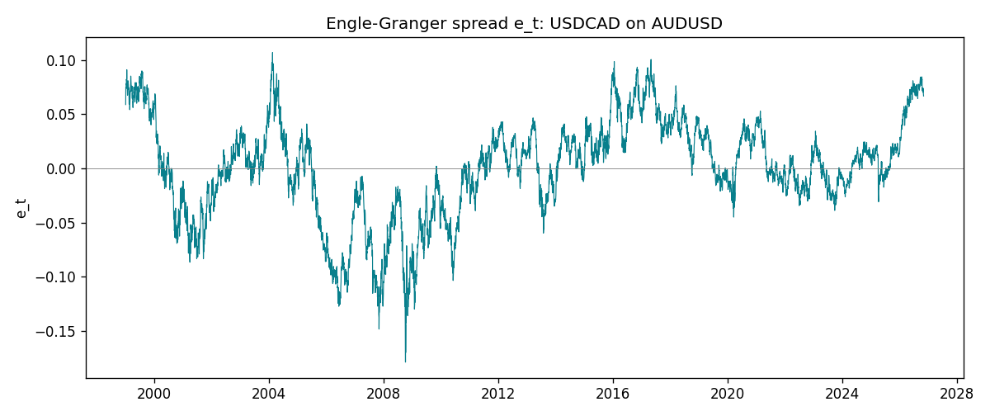
Daily log returns
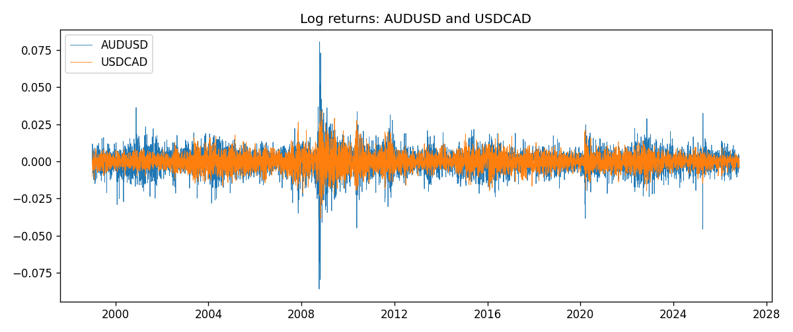

Data report
Matched rows are in the sibling Excel workbook named AUDUSD-USDCAD_Coint_D1.xlsx. Embedding all rows as a Word table is impractical; this file holds column summaries and the first and last 15 matched rows.
Column summaries
column | count | mean | std | min | 25% | 50% | 75% | max
AUDUSD_open | 7204 | 0.75193151 | 0.13526075 | 0.4785 | 0.6610425 | 0.731405 | 0.8086175 | 1.10284
USDCAD_open | 7204 | 1.2670146 | 0.16899756 | 0.9168 | 1.118975 | 1.298545 | 1.372225 | 1.6183
AUDUSD_high | 7204 | 0.7559812 | 0.13582551 | 0.4878 | 0.6647 | 0.734785 | 0.81467 | 1.10795
USDCAD_high | 7204 | 1.2719163 | 0.16895637 | 0.9336 | 1.123375 | 1.30394 | 1.3767575 | 1.619
AUDUSD_low | 7204 | 0.74787477 | 0.13457623 | 0.4775 | 0.6577 | 0.727495 | 0.8042 | 1.0975
USDCAD_low | 7204 | 1.2624553 | 0.16903522 | 0.9056 | 1.11435 | 1.293585 | 1.3678925 | 1.6102
AUDUSD_close | 7204 | 0.75197934 | 0.13524694 | 0.4786 | 0.6611975 | 0.731695 | 0.808875 | 1.10169
USDCAD_close | 7204 | 1.2670334 | 0.16897258 | 0.916 | 1.11848 | 1.298615 | 1.372515 | 1.6137
AUDUSD_tick_volume | 7204 | 77316.143 | 138115.43 | 109 | 5421.75 | 43310.5 | 71296.75 | 1234623
USDCAD_tick_volume | 7204 | 80846.476 | 147183.52 | 56 | 5511.25 | 40857 | 71531.75 | 1410818
AUDUSD_spread | 7204 | 30.823709 | 16.885829 | 0 | 13 | 30 | 50 | 50
USDCAD_spread | 7204 | 23.505275 | 18.28107 | 0 | 9 | 17 | 40 | 60
AUDUSD_real_volume | 7204 | 5.2399076e+09 | 1.2535442e+11 | 0 | 0 | 0 | 0 | 3.811512e+12
USDCAD_real_volume | 7204 | 1.8332738e+10 | 9.6584767e+10 | 0 | 0 | 0 | 0 | 2.5751613e+12
AUDUSD_log_price | 7204 | -0.3008009 | 0.17688781 | -0.7368901 | -0.41370269 | -0.31239152 | -0.21211091 | 0.09684536
USDCAD_log_price | 7204 | 0.22751758 | 0.13649379 | -0.08773891 | 0.11197062 | 0.26129831 | 0.31664482 | 0.47852968
AUDUSD_log_return | 7204 | 2.007e-05 | 0.0075444 | -0.08602525 | -0.00386183 | 0.00027895 | 0.00414528 | 0.0806166
USDCAD_log_return | 7204 | -1.21e-05 | 0.00514438 | -0.03859748 | -0.00283637 | 4.97e-05 | 0.00272781 | 0.03436319
spread_e | 7204 | -0 | 0.04562363 | -0.1789526 | -0.02340821 | 0.0037318 | 0.02916129 | 0.10710453
ecm_fitted | 7203 | -1.07e-05 | 0.00020555 | -0.00098879 | -0.00013554 | -1.976e-05 | 0.00010483 | 0.0015301
First 15 matched rows (selected columns)
time | AUDUSD_log_price | USDCAD_log_price | spread_e | AUDUSD_log_return | USDCAD_log_return
1999-01-05 | -0.47561937 | 0.41363167 | 0.058975972 | -0.00080418179 | -0.010131666
1999-01-06 | -0.46378302 | 0.41330099 | 0.067253375 | 0.011836351 | -0.0003306769
1999-01-07 | -0.45491799 | 0.4148212 | 0.075220744 | 0.0088650256 | 0.0015202092
1999-01-08 | -0.45460283 | 0.41277168 | 0.073400427 | 0.00031515916 | -0.0020495197
1999-01-11 | -0.44738145 | 0.40925791 | 0.075138457 | 0.0072213815 | -0.0035137769
1999-01-12 | -0.4522423 | 0.41587738 | 0.078222838 | -0.0048608485 | 0.0066194721
1999-01-13 | -0.46013251 | 0.4204194 | 0.077026642 | -0.0078902098 | 0.0045420214
1999-01-14 | -0.46282943 | 0.42735705 | 0.082002943 | -0.002696916 | 0.0069376546
1999-01-15 | -0.45570632 | 0.42166649 | 0.081492708 | 0.007123101 | -0.0056905671
1999-01-18 | -0.4547604 | 0.42264993 | 0.083164084 | 0.00094592471 | 0.00098344542
1999-01-19 | -0.44753788 | 0.42539845 | 0.091165229 | 0.0072225153 | 0.002748513
1999-01-20 | -0.4462871 | 0.41943376 | 0.086110182 | 0.0012507819 | -0.0059646885
1999-01-21 | -0.44550616 | 0.41515138 | 0.08239575 | 0.00078094498 | -0.0042823796
1999-01-22 | -0.4577589 | 0.41765715 | 0.075990615 | -0.012252745 | 0.0025057712
1999-01-25 | -0.46171805 | 0.41851295 | 0.073967092 | -0.0039591468 | 0.00085579808
Last 15 matched rows (selected columns)
time | AUDUSD_log_price | USDCAD_log_price | spread_e | AUDUSD_log_return | USDCAD_log_return
2026-10-13 | -0.35923536 | 0.3516423 | 0.081627796 | 0.0035007712 | -0.0046395653
2026-10-14 | -0.36075468 | 0.35316078 | 0.082041333 | -0.0015193215 | 0.0015184751
2026-10-15 | -0.36829939 | 0.34955063 | 0.072944235 | -0.0075447063 | -0.0036101503
2026-10-16 | -0.36490875 | 0.34611842 | 0.071977898 | 0.0033906408 | -0.0034322068
2026-10-19 | -0.35982275 | 0.34423489 | 0.073793198 | 0.0050859986 | -0.0018835331
2026-10-20 | -0.35636071 | 0.34052829 | 0.072604395 | 0.0034620426 | -0.0037066008
2026-10-21 | -0.35275407 | 0.33968137 | 0.074380434 | 0.0036066384 | -0.00084691787
2026-10-22 | -0.35402133 | 0.33705064 | 0.070828085 | -0.0012672558 | -0.0026307268
2026-10-23 | -0.35164476 | 0.3370792 | 0.072585016 | 0.0023765656 | 2.85545e-05
2026-10-26 | -0.35484804 | 0.3371363 | 0.07031251 | -0.0032032829 | 5.7106554e-05
2026-10-27 | -0.35318105 | 0.33967425 | 0.074062785 | 0.0016669876 | 0.0025379458
2026-10-28 | -0.3490895 | 0.33583632 | 0.073200473 | 0.0040915541 | -0.0038379274
2026-10-29 | -0.35318105 | 0.33572196 | 0.070110493 | -0.0040915541 | -0.00011436495
2026-10-30 | -0.35217082 | 0.33469208 | 0.069815323 | 0.0010102376 | -0.0010298736
2026-11-02 | -0.35708932 | 0.33530727 | 0.066853497 | -0.0049184984 | 0.00061519094

